Penelope sings

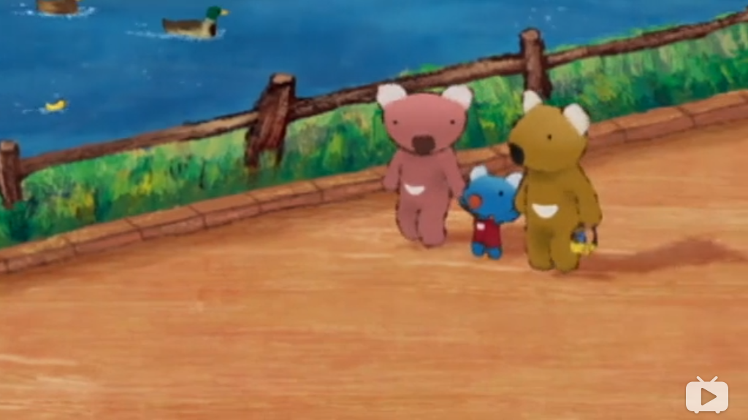

Penelope is going for a walk.

I learnt a song at school today.

Really?

How does it go?

She looks proud. Sing for Mum and Dad.

Hop and hop and...uh...

hop and hop and...uh...

which animal hops? Erm... elephants!

Hop and hop,a hopping elephant.

An elephant? Really? But can elephants hop?

Aren't they too heavy? What do you think?

Hop and hop and...oh,wait, that's not right.

Hoping? Uh... a rabbit!

Hop and hop,a hopping rabbit.

Hop and hop,a hopping rabbit.

Swim and swim ,Erm ...swim and swim,a swimming cat.

A cat? A poor little cat?But cats don't like water. I wonder who swims.

Swimming...fish!

Swim and swim,a swimming fish.

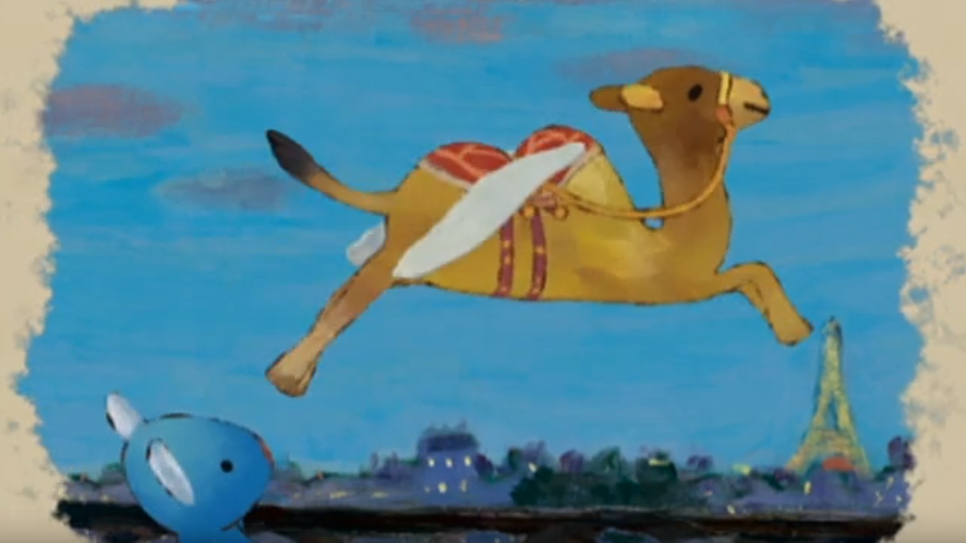

Fly and fly,a flying camel.

Wow..

A flying camel? Really?But can camels fly?

Mmm... What flies?

Flying...Butterfly!

Fly and fly,a flying butterfly.

Wiggle wiggle,a wiggling sheep.

The sheep? Really? But do sheep wiggle?

Wiggling...snake! Wiggle wiggle,a wiggling snake.

Hop and hop,a hopping rabbit

Swim and swim,a swimming fish

Fly and fly,a flying butterfly

Wiggle wiggle,a wiggling snake

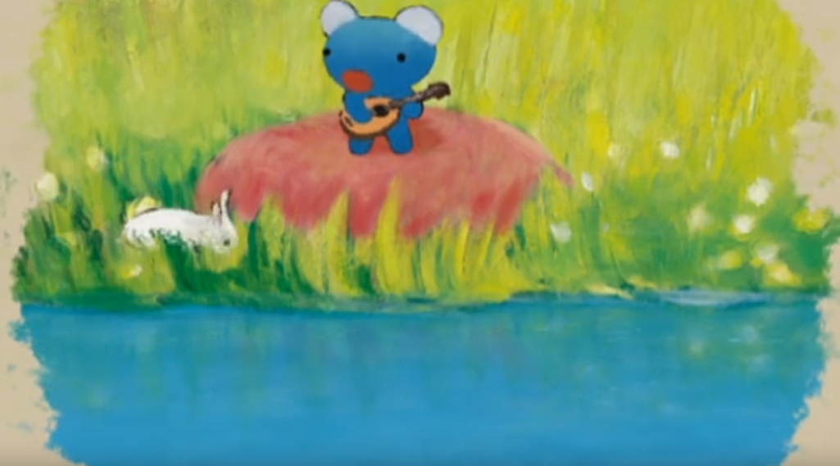

Haha..what a lovely singer you are!

Oh, my penelope.

Heehee...

Hop hop swim swim fly fly and wiggle wiggle

Now who runs? Do you know?

Penelope!

Come here!

Coming, Dad, Mum.

Yes, it's Penelope.

Heehee...

Haha...

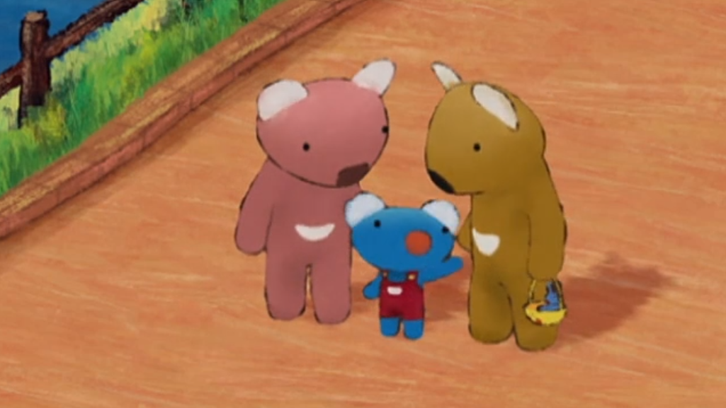

Hop and hop,a hopping rabbit

Swim and swim,a swimming fish

Fly and fly,a flying butterfly

Wiggle wiggle,a wiggling snake

Run run run,She runs so fast.

Look at how Penelope runs.

Run run run ,I run so fast.

Look at how I run so fast.